Integrated Sales Performance Analysis: Mapping Trends & Identifying Weaknesses
Tableau:
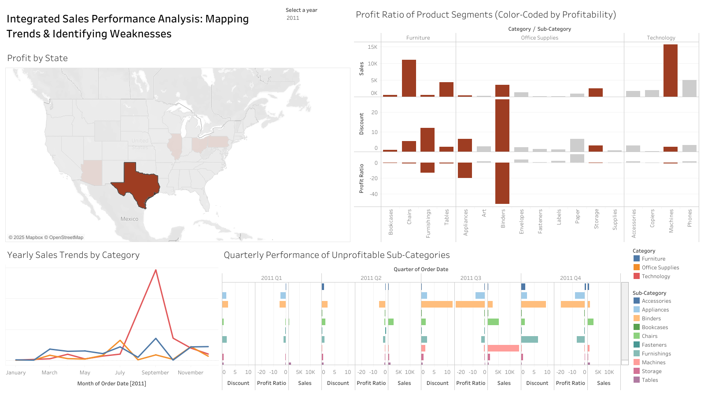
https://public.tableau.com/app/profile/greg.charles/viz/RegionalUnderperformanceSpotlight/Dashboard1#1
How does your visualization leverage at least one “pop-out effect” or “pre-attentive attribute?” Which one(s) was (were) chosen and why?
To ensure key insights are immediately noticeable, the visualization strategically employs several pre-attentive attributes across its different charts:

- Profit by State Map: Primarily utilizes color (hue) to create a strong pop-out effect for states experiencing losses, which are displayed in red. States with profit (zero or above) are shown in grey. This binary color scheme immediately directs Sylvia's attention to geographically underperforming areas. Clicking on a state further creates a powerful change in the visual field across the entire dashboard, focusing on the regional performance.
- Yearly Sales Trends by Category: Uses hue (different colors for each category) to allow for easy visual differentiation and tracking of individual category sales trends over time. The dynamic filtering by state also creates a pop-out effect for regional category performance.
- Quarterly Performance of Unprofitable Sub-Categories: Employs hue to distinguish the trend lines of different unprofitable sub-categories. Assigning a unique color to each Sub-Category allows for easy visual tracking of individual product performance and trends over the quarters where they incurred losses. The filtering itself to focus solely on loss-making sub-categories creates a strong pop-out effect, directing attention to these critical areas.
- Profit Ratio of Product Segments: Primarily uses color (hue), with red specifically highlighting product segments with a negative profit ratio and grey indicating segments with zero or positive profit ratio. This allows Sylvia to quickly identify unprofitable product areas.
How does your visualization utilize at least one Gestalt principle? Which principle(s) is (are) being reflected, and how?
The dashboard design incorporates Gestalt principles of visual perception to help Sylvia intuitively understand the relationships and organization within the data:
- Proximity: Related charts are positioned near each other on the dashboard, suggesting a connection in the data being presented.
- Connectedness: The interactive filtering by state links the visualizations together. Selecting a state on the map immediately updates all other charts, creating a strong visual and cognitive connection between geographic performance and other sales dimensions.
- Similarity: The consistent use of red to indicate losses across the Profit by State map and the Profit Ratio of Product Segments reinforces the concept of negative profitability throughout the dashboard. Similarly, grey consistently represents non-loss situations.
- Continuity: In the line charts (Yearly Sales Trends and Quarterly Performance of Unprofitable Sub-Categories), the lines allow users to easily follow the trend of sales or profit ratio over time for each category or sub-category.

How does your design reflect an understanding of cognitive load and clutter?
To minimize cognitive load and ensure the dashboard is easy for Sylvia to interpret, several design strategies have been implemented:
- Clear and Familiar Chart Types: Standard chart types are used for easy interpretation.
- Strategic Use of Color: The simplified two-color scheme (grey/red for profit) reduces visual complexity and immediately highlights the most critical information (losses). Other colors (hues) are used to differentiate categories and sub-categories without encoding the primary profit message.
- Informative Titles: Each chart has a title explaining its content.
- Interactive Filtering: Allows users to focus on specific subsets of the data, reducing the amount of information displayed at once.
- Conditional Labeling (inferred for the line charts): Labels are likely used selectively to avoid overwhelming the view.
- Tooltips: Providing detailed values on hover for all relevant fields (Sum(Sales), Sum(Discount), Sum(Profit Ratio), Category, Sub-Category, State, Year, Quarter, Month, etc.) prevents the charts from being cluttered with excessive direct labels while still offering precise data and context when Sylvia needs it.
- Logical Layout: Charts are arranged to suggest a flow of analysis.
- Strategic Use of Detail: The Detail mark is used in the Yearly Sales Trends by Category chart to ensure that separate lines are drawn for each Category, providing the necessary level of granularity for comparing individual category performance over time without adding visual clutter through additional charts.

Is your visualization static or interactive? Why did you choose that format?
The dashboard is designed to be interactive to empower Sylvia to explore the data and gain deeper insights relevant to her specific needs. The ability to filter by state (via map action and standard filter) and by year allows Sylvia to explore the data dynamically, focusing on specific regions and timeframes to understand the context of profitability and losses. This interactivity, combined with the detailed information available in the tooltips, is crucial for targeted decision-making regarding inventory, distribution, and sales strategies. The simplified color scheme enhances the effectiveness of this interactive exploration by making losses immediately apparent, and the tooltips provide the underlying data to support those visual cues.

What need does this visualization address that words or numbers alone cannot fill?
This interactive dashboard addresses Sylvia's need to quickly and intuitively understand the complex sales performance of ACME Superstore across multiple dimensions (geography, product category, sub-category, and time), with a particular emphasis on identifying areas of unprofitability. The visual representations, especially the use of red for losses across the map and product segment charts, provide an immediate and impactful understanding of where the business is struggling financially. The interactivity allows her to explore these losses within specific geographic and temporal contexts, with tooltips offering the precise numerical data behind the visual trends and patterns. The trend lines for unprofitable sub-categories, differentiated by color thanks to the Sub-Category on the Color mark, further illustrate the evolution of these losses for specific products over time. The Detail mark in the category trends ensures clear separation of category performance. This visual and interactive approach, supplemented by detailed information in the tooltips, enables Sylvia to rapidly pinpoint problem areas and make informed strategic decisions to mitigate losses and improve overall profitability, far more effectively than reviewing static reports or tables of data.

